**SECURITY MONITORING DASHBOARD**

Security monitoring dashboard of snowflake tasks is used to effectively manage task-related security privileges and activities.You can track the altered history of tasks using this dashboard. Security Monitoring Dashboard provides a comprehensive view of all task-related security privileges, activities, and changes.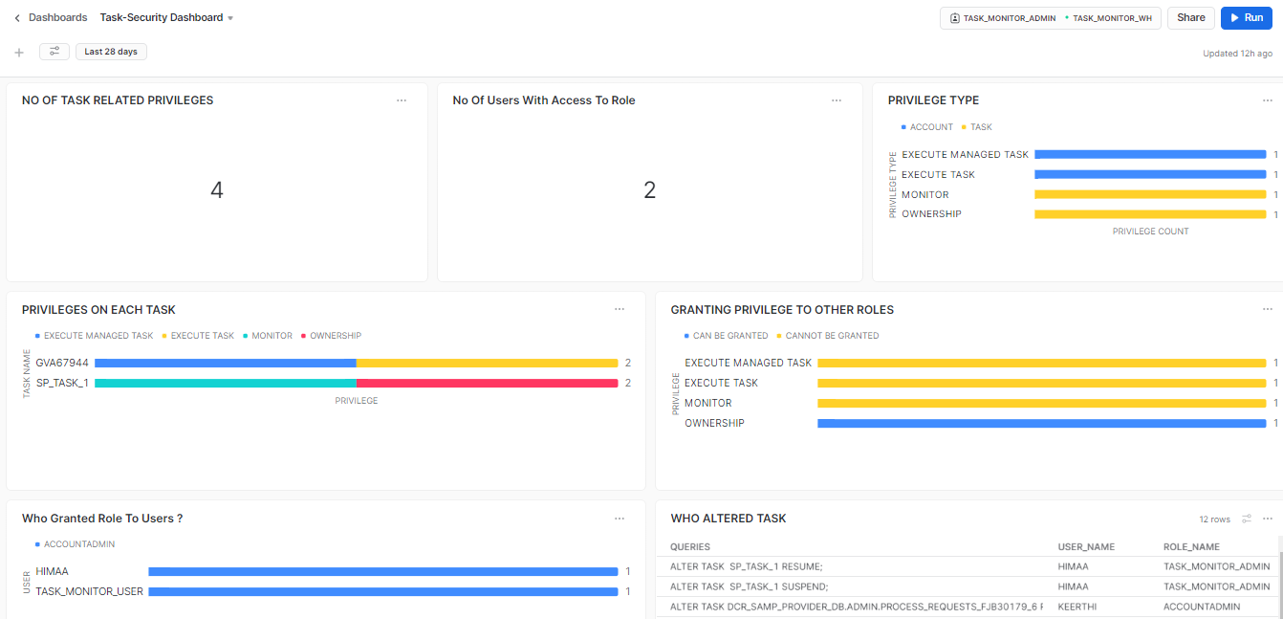

**FILTERS:**

* **DATERANGE(Default Filter)**

**3.1 NO OF TASK RELATED PRIVILEGES:**

SELECT count(*) FROM SNOWFLAKE.ACCOUNT_USAGE.GRANTS_TO_ROLES WHERE GRANTEE_NAME=CURRENT_ROLE() AND (GRANTED_ON ='TASK' OR PRIVILEGE IN ('EXECUTE MANAGED TASK','EXECUTE TASK') ) AND DELETED_ON IS NULL ;

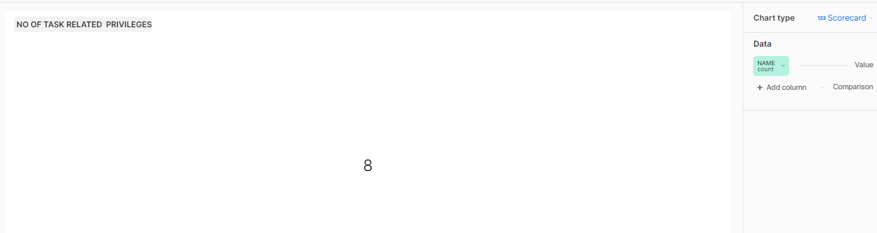

**3.2 No Of Users With Access To Role:**

SELECT GRANTEE_NAME AS USER,GRANTED_BY ,CREATED_ON FROM SNOWFLAKE.ACCOUNT_USAGE.GRANTS_TO_USERS WHERE GRANTED_TO='USER'

AND DELETED_ON IS NULL

AND

ROLE= CURRENT_ROLE();

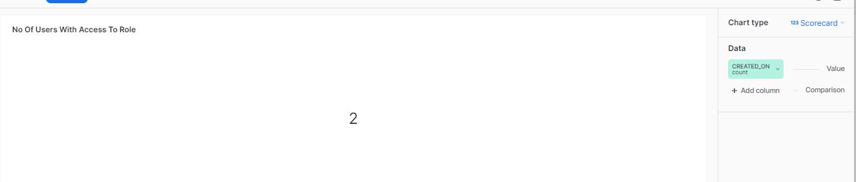

**3.3 PRIVILEGE TYPE:**

SELECT PRIVILEGE, granted_on FROM SNOWFLAKE.ACCOUNT_USAGE.GRANTS_TO_ROLES WHERE GRANTEE_NAME=CURRENT_ROLE() AND (GRANTED_ON ='TASK' OR PRIVILEGE IN ('EXECUTE MANAGED TASK','EXECUTE TASK') ) AND DELETED_ON IS NULL;

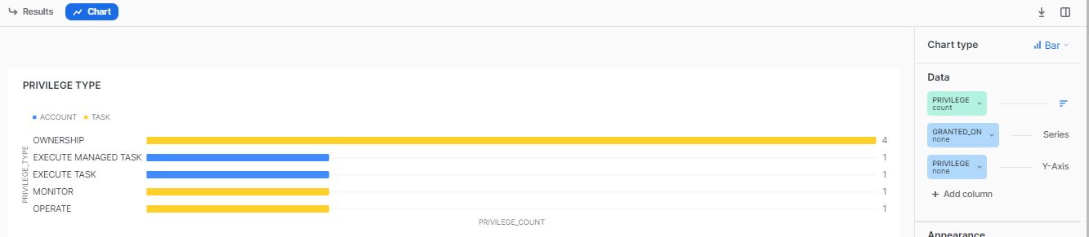

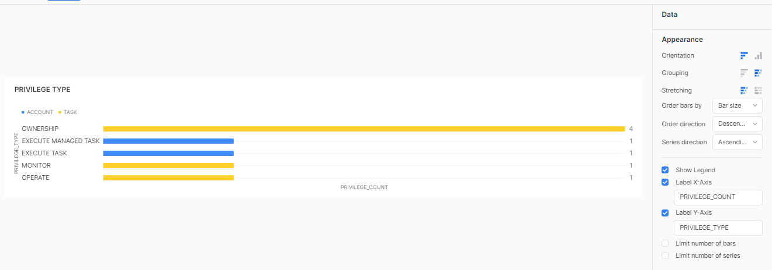

**3.4 PRIVILEGES ON EACH TASK:**

SELECT * FROM SNOWFLAKE.ACCOUNT_USAGE.GRANTS_TO_ROLES WHERE GRANTEE_NAME=CURRENT_ROLE() AND (GRANTED_ON ='TASK' OR PRIVILEGE IN ('EXECUTE MANAGED TASK','EXECUTE TASK') ) AND DELETED_ON IS NULL;

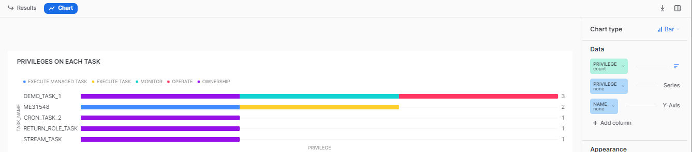

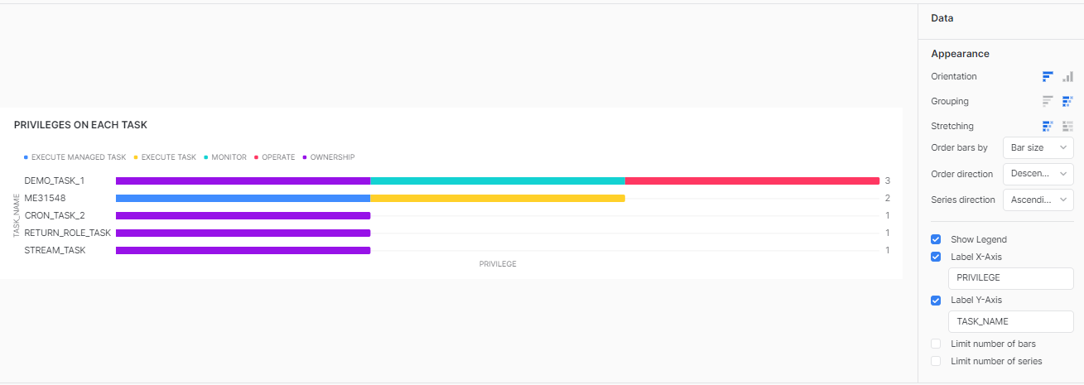

**3.5 TASK CATEGORY:**

SELECT NAME as TASK_NAME ,QUERY_TEXT,STATE AS STATUS,

CASE

WHEN lower(QUERY_TEXT) like '%insert%' AND upper(CONDITION_TEXT) like '%SYSTEM$STREAM_HAS_DATA%' THEN 'CDC'

WHEN lower(QUERY_TEXT) like '%insert%' THEN 'Ingestion'

WHEN lower(QUERY_TEXT) like '%copy into%' THEN 'Loading'

WHEN lower(QUERY_TEXT) like '%describe%' THEN 'Verify Metadata'

WHEN lower(QUERY_TEXT) like '%update%' THEN 'Modification'

WHEN lower(QUERY_TEXT) like '%select%' THEN 'Retrieval'

WHEN lower(QUERY_TEXT) like '%drop%' THEN 'Management'

WHEN lower(QUERY_TEXT) like '%call%' THEN 'Calling_Procedure'

ELSE 'Others'

END AS category

FROM SNOWFLAKE.ACCOUNT_USAGE.TASK_HISTORY

WHERE STATUS='SUCCEEDED' AND TASK_NAME IN (SELECT NAME FROM SNOWFLAKE.ACCOUNT_USAGE.GRANTS_TO_ROLES WHERE GRANTEE_NAME=CURRENT_ROLE() AND (GRANTED_ON ='TASK' OR PRIVILEGE IN ('EXECUTE MANAGED TASK','EXECUTE TASK') ) AND DELETED_ON IS NULL) ;

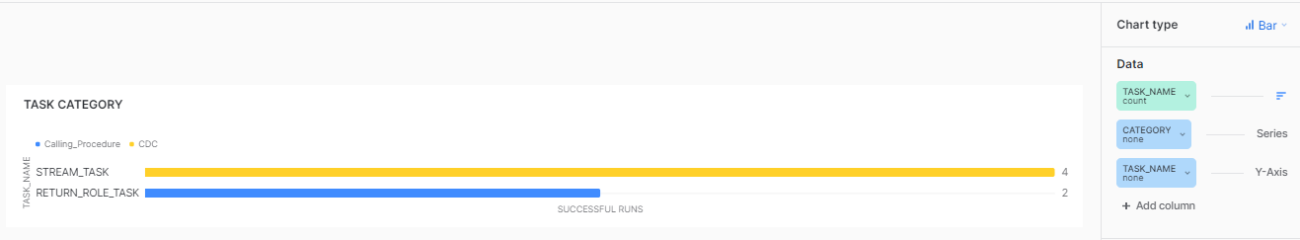

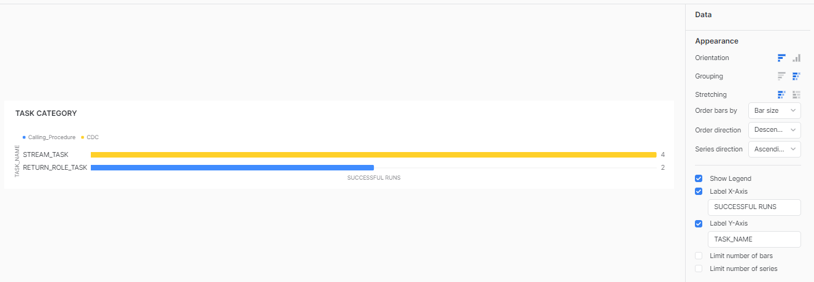

**3.6 GRANTING PRIVILEGE TO OTHER ROLES:**

SELECT NAME AS TASK_NAME, PRIVILEGE,

CASE

WHEN GRANT_OPTION = 'FALSE' THEN 'CAN BE GRANTED'

ELSE 'CANNOT BE GRANTED'

END AS GRANT_OPTION

FROM SNOWFLAKE.ACCOUNT_USAGE.GRANTS_TO_ROLES WHERE GRANTEE_NAME=CURRENT_ROLE() AND (GRANTED_ON ='TASK' OR PRIVILEGE IN ('EXECUTE MANAGED TASK','EXECUTE TASK') ) AND DELETED_ON IS NULL;

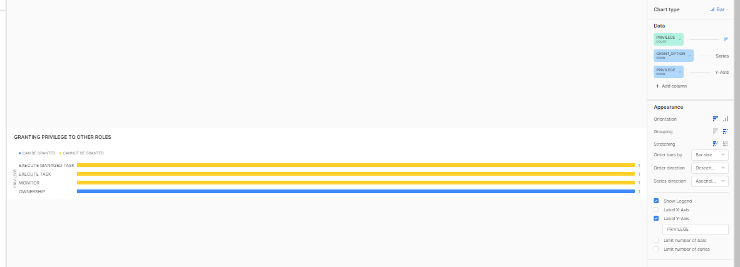

**3.7 Who Granted Role To Users ?:**

SELECT GRANTEE_NAME AS USER,

IFNULL( GRANTED_BY , 'NONE' ) AS GRANTED_BY,

CREATED_ON FROM SNOWFLAKE.ACCOUNT_USAGE.GRANTS_TO_USERS WHERE GRANTED_TO='USER'

AND

ROLE= CURRENT_ROLE() AND DELETED_ON IS NULL;

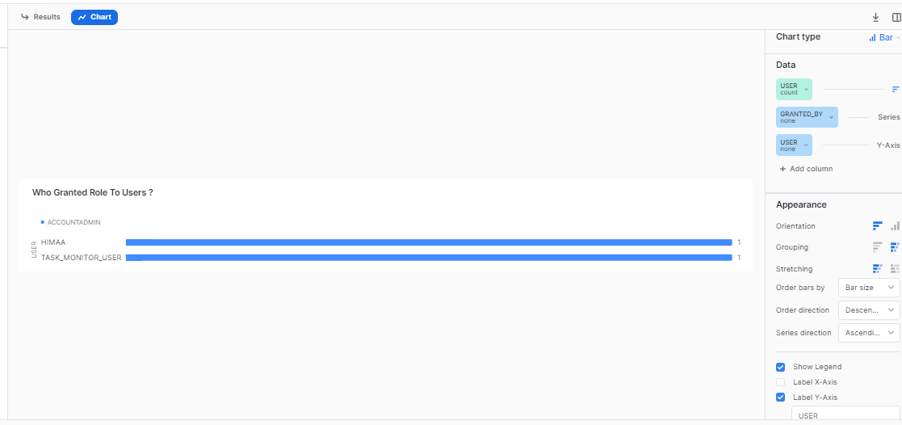

**3.8 WHO ALTERED TASK:**

select * from ( Select

upper(QUERY_TEXT) as QUERIES,

USER_NAME,

ROLE_NAME,

START_TIME

from

SNOWFLAKE.ACCOUNT_USAGE.QUERY_HISTORY

where START_TIME=:daterange and

query_type in ('ALTER')

And upper(QUERY_TEXT) like 'ALTER TASK%'

and execution_status = 'SUCCESS'

and USER_NAME in (

Select

Distinct(Name)

from

snowflake.account_usage.users

where

deleted_on is null)

);

